English Language Support Programmes
for COGNITA Students
with 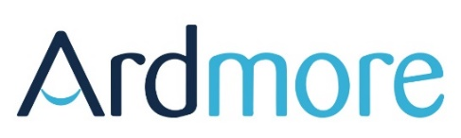

Fees

Course | Number of lessons* | Fees
Pre-Arrival to the UK | 10 individual lessons | £415
Summer School Programme in the UK – group lessons – per week | 20 lessons per week + full activity programme -Day | £395
Summer School Programme – Group lessons only – per week | 20 lessons per week | £225
Term-time afterschool lessons – Course A | 2 individual lessons per week (10 weeks) | £810
Term-time afterschool lessons – Course B | 1 individual lesson per week (10 weeks) | £415
Academic Year afterschool lessons | 30 individual lessons | £1,175
Half Term, Easter & Christmas Courses | 2 individual lessons per day (5 days) | £415
Half Term, Easter & Christmas Courses | 3 individual lessons per day (5 days) | £605
Half Term, Easter & Christmas Courses | Additional English-led Activity Programme | £245
Ardmore X - Access for Self-Study | Access to educational materials | £150  per term
Ardmore X - Guided Self-Study | Access to educational materials with teacher guidance and feedback on written and spoken activities | £300  per term
Language Courses for Parents | 10 individual lessons | £425
* All lessons are 45-minutes unless stated

